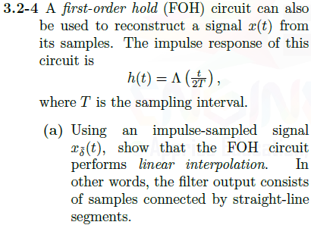

a) $x_{\tilde{δ}}\left(t\right)$ will be scaled impulses of $x(t)$ separated by the sampling period $T_{s}$. Then,

$$y\left(t\right)=x_{\tilde{δ}}\left(t\right)*h\left(t\right)=\left(\sum_{n= -∞}^{∞}{x\left(nT\right)}\right)*h\left(t\right)=\sum_{n= -∞}^{∞}{x\left(nT\right)}Λ\left(\frac{t-nT}{2T}\right) (see pg.165)$$

Stealing your code from pg. 166 in the textbook, we can see what this looks like in MATLAB with sampling periods of 0.5s, 0.2s and 0.1s

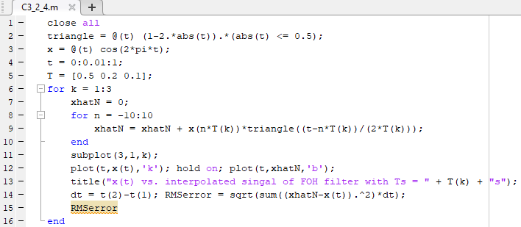 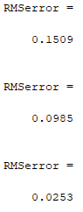

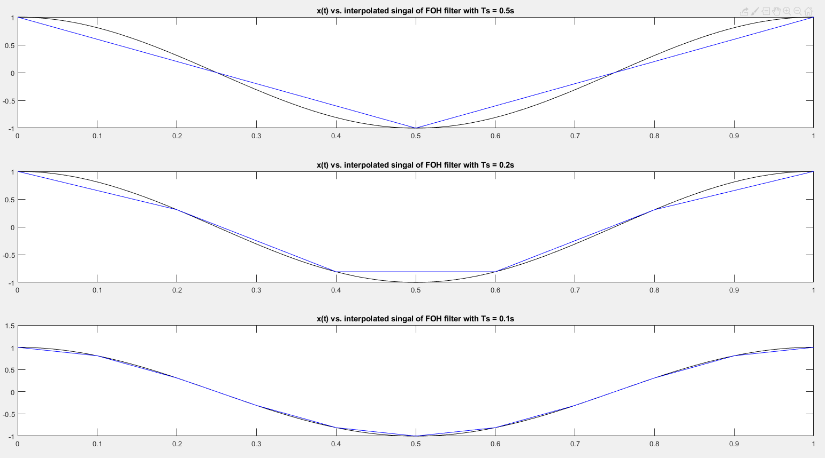

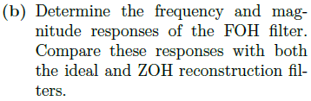

$$h\left(t\right)= Λ\left(\frac{t}{2T}\right)$$

Using transform pair: 

Then, $H\left(ω\right)=Tsinc^{2}\left(\frac{ωT}{2π}\right)$ where $sinc=\frac{sin⁡(πt)}{πt}$

We can steal the frequency domain equations for ZOH and ideal reconstruction filters from pg. 167 and 164 respectively

Then in MATLAB,

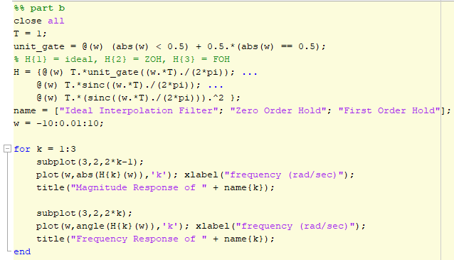

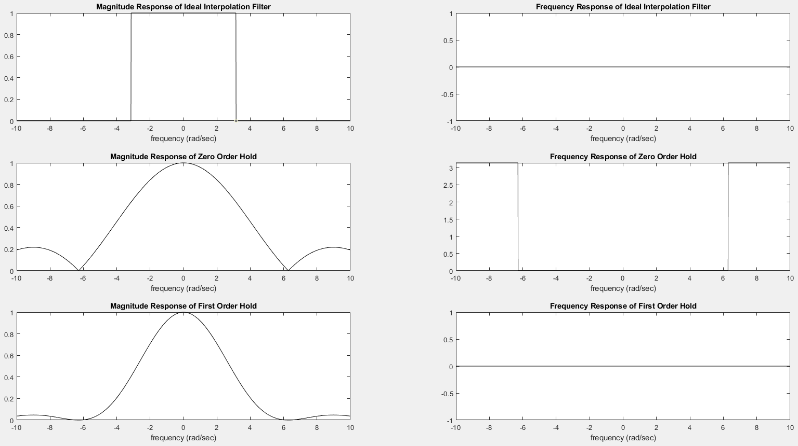

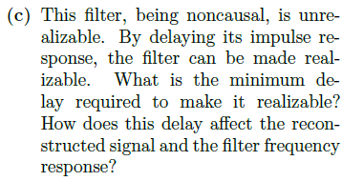

Currently, the impulse response is a Triangle model, centered on t = 0, with limbs that go out to from -T to T. Then the minimum delay necessary to make this filter realizable (causal) is one period “T”.

$$x_{FOH_{Delayed}}\left(t\right)= \sum_{n=-∞}^{∞}{x(nT)}Λ\left(\frac{t-T-nT}{2T}\right)$$

If we delay $h(t)$ by one sampling period it will be identical to the FOH except that the output will be delayed by one sample period. In MATLAB if we let T = 1,

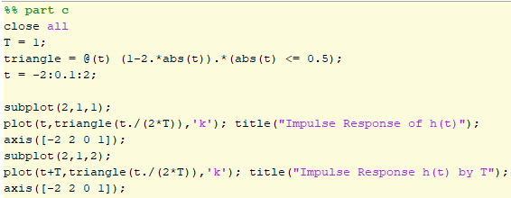

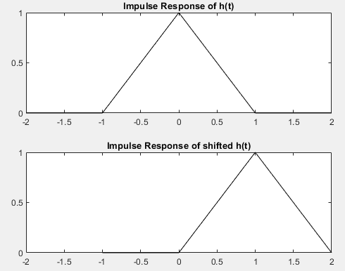

Or in MATLAB using our same code from part a,

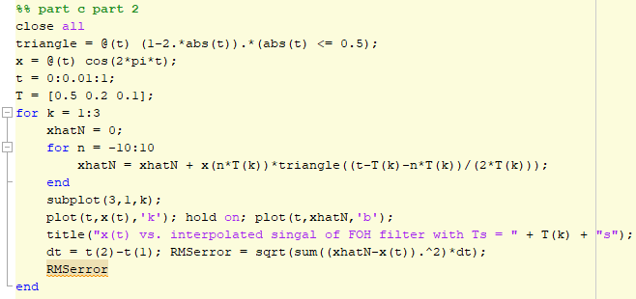 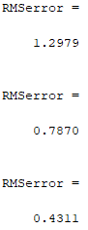

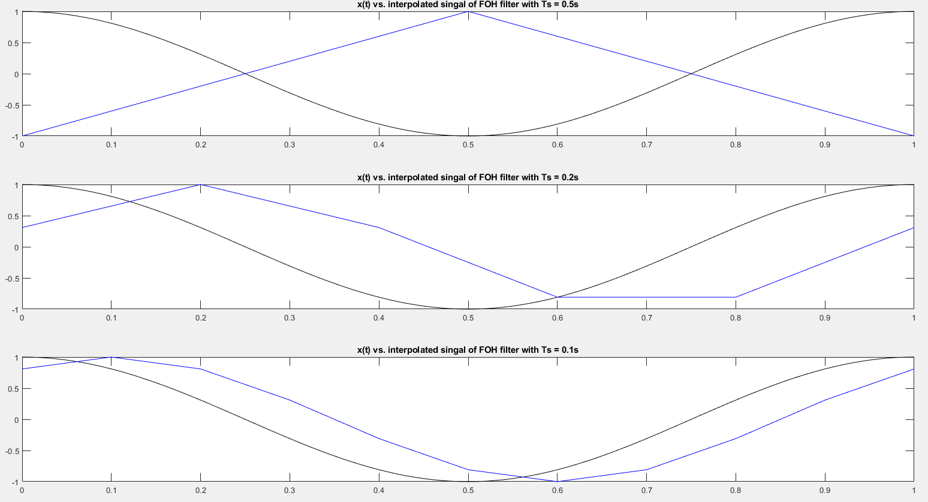

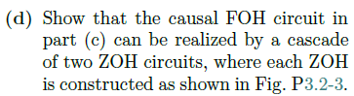

$$H_{ZOH}\left(ω\right)=Tsinc\left(\frac{ωT}{2π}\right) see pg. 167$$

Cascaded systems multiply in the frequency domain, so:

$$H_{ZOH_{twice cascaded}}\left(ω\right)=Tsinc\left(\frac{ωT}{2π}\right)Tsinc\left(\frac{ωT}{2π}\right)=T^{2}sinc^{2}\left(\frac{ωT}{2π}\right)$$

From the FOH transform pair, we know that in the time-domain this is:

$$h_{ZOH_{twice cascaded} }\left(t\right)=TΛ\left(\frac{t}{2T}\right)$$

This will be the same as FOH circuit, except scaled by T. In our case if we use the same $T=0.5, 0.2, 0.1$ then in MATLAB:

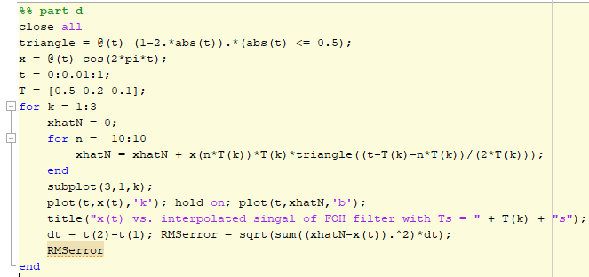

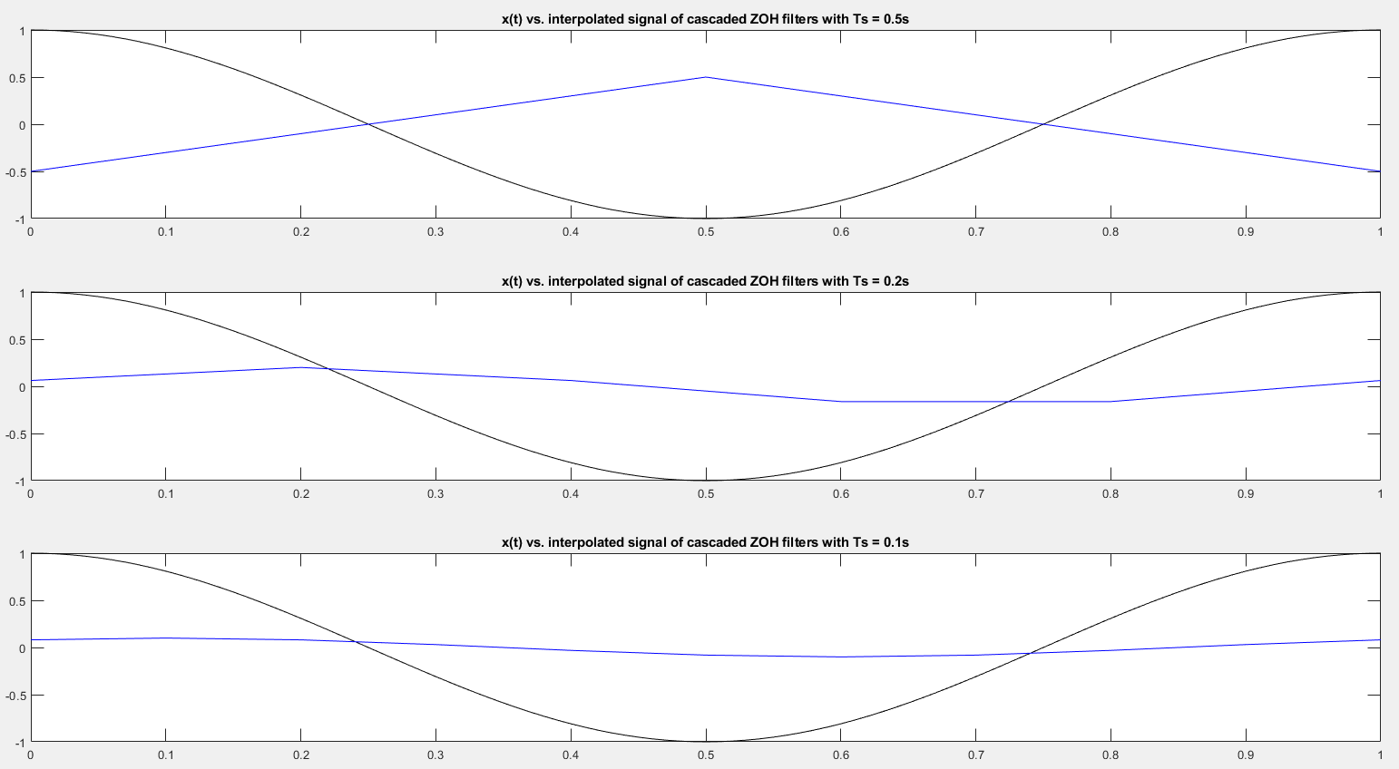

These are the same values as our FOH filter except scaled by T.